I 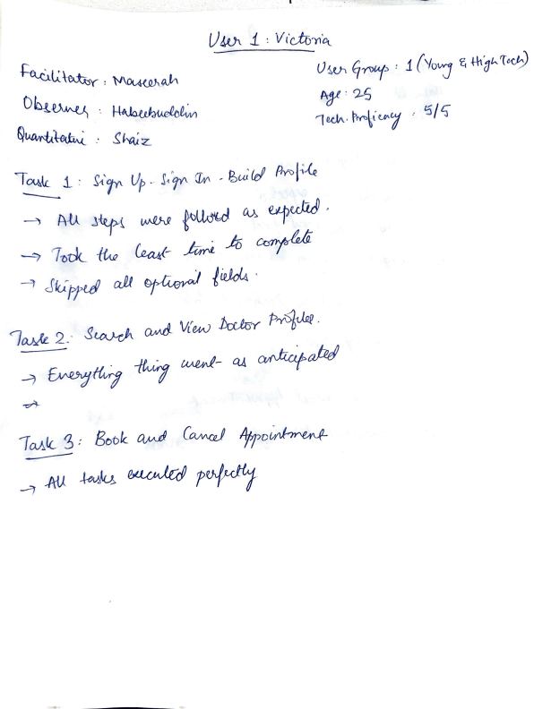

***U i* : *V* (c.ltrYl *ot***

*Uw.* 9~:, , *1 ('-toj ~tft-'roet;)*

*~:* 9-5

1 rj,\ . *~""vu-;* , *15* / *t:;*

i • .\'l';r- *Up. !,~ (Ly,* - *fbw'&/* ***AYol~***

-') A-U .a~ ,

*'11>dc tfM Ult»/- _Jo*

_,, *JkiptuR aPJ i~* •

*f f.Vfl.* 2_ · $~ *V{ew ~Y P~thi.*

-7*ry* ~- *Q,! ~a/Rd*

*1~/c 3:* Soule *Co.MW 4tr~*

*-=,* -AU*?~*

I 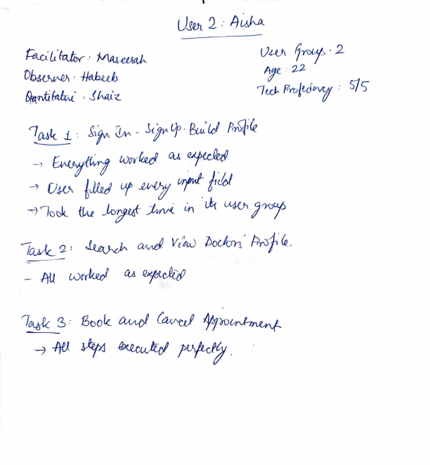

***UJVt* 2 ..** 4~M

~Li.'~· Mft.J.-W.PJ.- Uwi *fry·* 2 *0~* • .· *22- ~<r.Ji~·* · ***Jh4i<-*** 7u-J. l?YD/tJ~ *: f;/c;  :__o.k* L: *g,~* - *~V,)3w'W Prrf)f~*

--~ ¥~ *tv~* Gu .~

*D~ '5JM U/~~f/d*

'7 'lat)k_ **{fN Jop** l11 **Lkt** L¼Oi *Jry* /ctYfc 2, *Q/v,d VticJ* /;;~' *P4'&l,* - -M *cu*

_s • *13boiz'Jo/ro~*

*~-IW*

U!QJ-L. b: D~A: 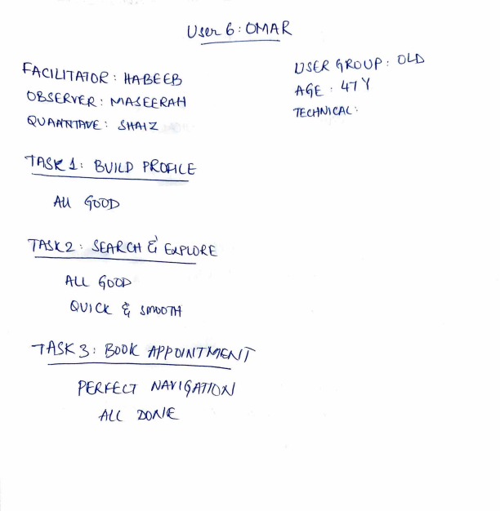

*usEJ<.* f)m0P, o~

{:l\e1 Ut M D/2 : }\·A-1?£ ffi ./\-~£.. , 41 '(  O'bSt.)(_v~ *t'-1'~ E.Ef<M-*

Q\) ~~""R'\lWf_ '. ~\-\{\-\ 7..

~l_2- -. S~<J-\ G bJ..PLOlE

'1-LL ~C)'CP

& V l ex_ l i'f\\)Dltt

,ASK 3 l 3001(_ *lrP/:J0/1'JTM~f/*

*PE!lF£a NA-Y t (jmtotJ*

*ALL 7:J.)l'l* L

*PA-e-tL111t.Tof* .' *'11-ffl 1z_ l>&~ VlzX:* .. M/tf *~ff ()l)AIJ7/71¥f{V(? : ~Hfll:Z*

/Af *J[ }* ·• *Bull/) P~DA£J* SMliO?H- *~I (iAf Uf _!.*

*U~ld!_ ~f!-OVP* _. *2 ~£: '57*

*·1£ct-f tJI CN-* : 1 / *5*

*COULD No? f-tlJD* tfst.JJLI.) *PR.iJAL( 1 tP'T700* 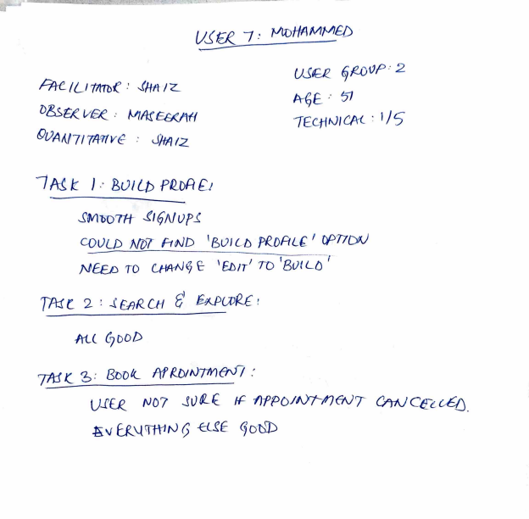

*NEF..__D TO Ufll-N9* £:- *'e.1J1r 1 'TD 1Bvt Lt)'*

/tl( *C7DDD*

7Af *K._ b : BDD* I{_ *ltf ~/ N71n tNl* .'

*UJ'f.-R_ ND? .JV dl* { *1-F- ftf P Nt-17 &JI &ttJ Cl£e..* l-6fj ~v ~'-t\ft\1tv 1 -E:LfE qo-$

*Pl\e_* U 1fflb~ */-fflf!,W!;J* 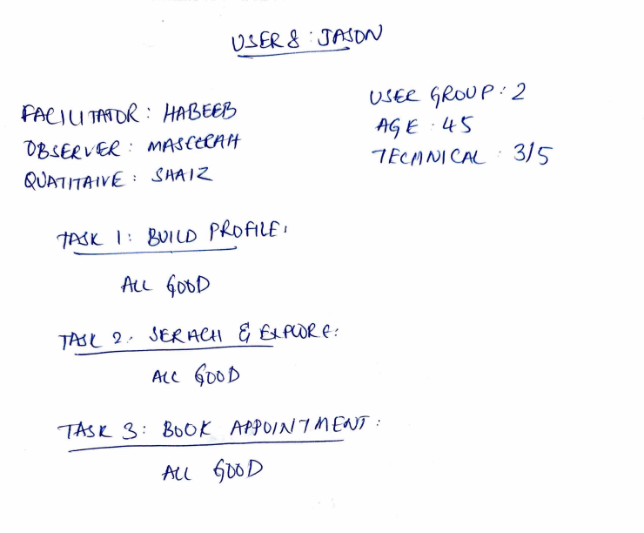

1>t.if£ *ve.¤ : M,Ml~tf/1-ff*

6<uA, *JTIH v* £ : AA *I* 2-

*1N,* t_ I : *&>1* LD P~Alf i

AlL 4o~P

TPdL 2 */* 0~~, e *&.Me_e-:* Aft ~T)t)i)

UJR *9R-,oU P* ·' *2 E* • *t+~*

*1 Ec__11 NI CAL* • 3/ S

r_ S *:* Bto *t- Mt 017'.i 1* kl *·ENT :* All *tjDO[)*

•-~- -- **4** 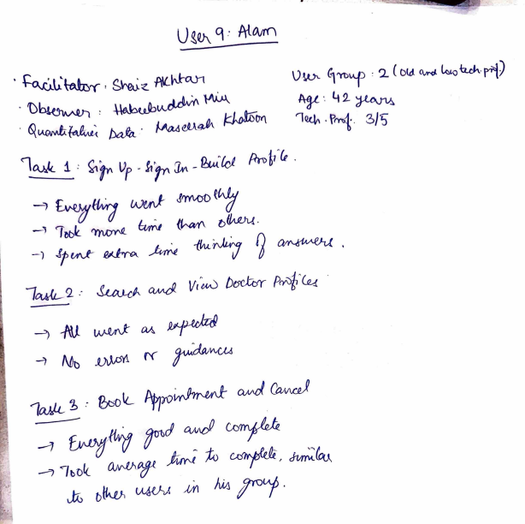

U SV\ 9 _. *M0vrn*

• ~lt'~Y-, s~<'.. *w~* \Jk,- 9"rbf , 2. *C* Did.~ ~~-r-~O  • 'D~ *:*~: lt *2-*

• *IQ~~* ***/)ak*** • **/Jw,~ *~tJ>'*'1~** . **f>rnf** 3/ij i_: *$;,fr' l)f* - *"1fr'* -*&t"(ol* Pr-oft, .

4~"7 *wuJ-* J'm-0()

-) *i,Ul.,f- -4mt -(t,u_~ g*'

_, *&mi t>~.*

70!ML-2 ••*Vt~ btJCtcrr Pm'/;,-~* ·

-) 1\/Jt).V\,W)1 ff *r~*

*-)-l'dJwW"t¾~*

*1cu4.- 2>* .. &,-olL. *'t;w~ cw.d*

*-1 &vtf¾~d~~*

_,, ~hol<_*k; to ~,*

*bltw,* Ml *Md/17°1,*

46.~~ ·. *g'htu.z_* ' ~eJott~Wl

U~ t(): *WKJL*

()~ *G,%¥:* ..2

*4o*

• *~ab,~* M. . *~w,.oJ,..* la~m, _i *: 1r' l)f* - f--t' *'Jr'* - *€>(,A.~ id ~{* 1' *le._*

-i -AAwtll.

-) ~9..

1~ 2 *:awJ* h'w b-t~ --) **-AU *w~v\£*** *u.;~*

*1~.* r~, .. *9-1~*

-f***r;w.'c.Jcvib~*** -(1;~ *u¥A* ,~- 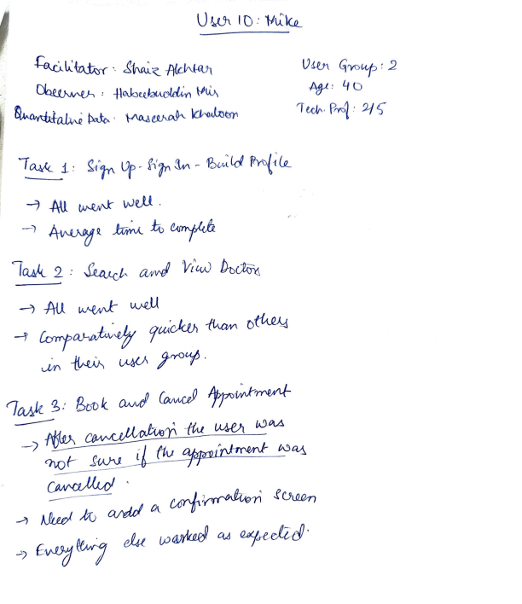

*</ev)r_ 2,:* BDo *k_ D.Ni4lfrw.l'~* -) *-ffu* lv.\-Vi

*~(-* ***$«N* ti *·ttv* e0Cl1**

--') *lli.rJ ,{i{) cwkl* .f  -!-)*ek. /)J~ cu;~·*